CALENDAR 2021-2022

VIRGINIA DECA DUE DATES AND EVENTS
JULY 2021 |  | JANUARY 2022

7-9 Chartered Association Officer Training Dulles, VA
- 10-12 Emerging Leader Summit Washington DC

26 Advisor Training (VAME Pre-Con) Virtual

27-29 VAME Summer Conference, Virtual

AUGUST 2021
- 3-5 MBA Conclave & DECA AMPED
SEPTEMBER 2021

3 DA & DP Training Registration Due

13 DLC Order Form Due (DAs) online
- 13 Stock Market Game begins
- 10-11 Board of Trustees Meeting Richmond, VA
- 21 State Fair Competition Registration Due Online
- 25-26 Leadership Retreat DAs & DPs, Smith Mountain Lake
- 27 – Oct 1 New Member Week
- 30 SLC Housing Form and Statement of Compliance Due Online
- 29 DECA Day at State Fair
OCTOBER 2021
- 11 VA DECA Executive Officer Applications Due
- 11 – 15 School-Based Enterprise Week

12 Competition Training – Chester

19 Competition Training - Blacksburg
- 19-29 Virtual Business Challenge Round 1
NOVEMBER 2021 – DECA MONTH

3 VA DECA Day
- 8-14 Global Entrepreneurship Week

15 Initial Online Membership Roster due
- 17-20 New York Experience I, New York, NY

19 Honor and Merit Applications Due online
- 19-21 The Ultimate Power Trip, Boston, MA
DECEMBER 2021
- 1 Campaigns due to National DECA
- 1-4 ACTE CareerTech VISION, New Orleans, LA + online
- 1-4 New York Experience II, New York, NY

3 VA DECA DAY Submission Due Online
- 10 Stock Market Game Ends
- 13 VA DECA Scholarship Applications Due
- 17 State Officer Applications Due
- 3-7 State Officer online testing
- 7 SLC Mini Grants Due

6-14 State Officer phone interviews
- 10 School-based Enterprise certification due

12 Last day for DLCs
- 14 Outstanding Chapter Advisor Award due
- 14 Friend of DECA Award due
- 14 Annual Report due to Donna Dail
- 14 National DECA Student Scholarship Apps due online
- 15 VA DECA Membership submitted/paid SLC eligibility
- 18-28 Virtual Business Challenge Round 2
- 25 SLC Registration Closes (last day drops with full refund)
- 28 DECA Emerging Leader Honor Award apps deadline
FEBRUARY 2022 CTE MONTH
- 2-6 Sports and Entertainment Conference Orlando, FL

4-5 SLC Conference Coordinators Meeting, VA Beach

7-11 Alumni Recognition Week

7 Written Events due online
- 7 SLC Last day for drops with partial refund
- 14 SLC Payment due
- 14-18 SLC Online Testing Window
- 14 Piper Sandler Taking Stock w/ Teens Spring Survey Begins
- 16 Last day for SLC Substitutions
- 28-29 VA DECA Scholarship Finalist Interviews

MARCH 2022
- 1 ICDC competitors’ eligibility
- 1 Advocacy Campaign Due National DECA

4-6 State Leadership Conference Va. Beach, VA

7-14 ICDC Registration Window

16 Piper Sandler Taking Stock w/ Teens Spring Survey Ends

28 ICDC Payment due (last day drops with partial refund)
APRIL 2022
- ICDC Qualifying Written Entry Submissions Due Online
- 23-26 ICDC Atlanta, GA

May 2021

May 13-14 VA DECA Board of Trustees Meeting, Richmond, VA
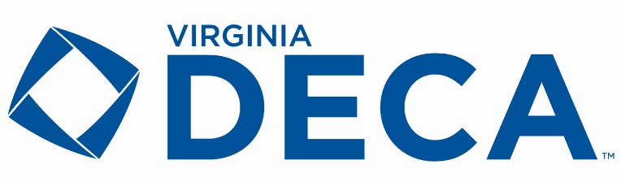
JUNE 2022

